Customer Contact: Media Contact:
Advantech Europe GmbH Advantech Europe GmbH
Customer Care Center Martin Skiba
Toll Free: 00800 24 26 80 80 Phone: +49 (0)211 97 477 363
customercare@advantech.eu martin.skiba@advantech.de

Advantech Launches Image-intensive Medical Applications with a 22” Wide Screen Point-of-Care Terminal
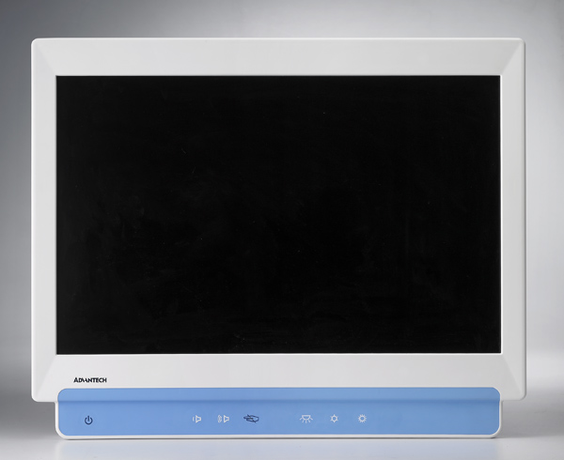
May 2010 – Advantech, the leading global ePlatform services provider, is happy to announce the POC-227 Point-of-Care terminal, running an Intel® Core™2 Duo processor with an Intel® GM45 Express chipset, and capable of delivering outstanding 3D graphics with its 22” WSXGA TFT LCD display. This high performance system is suitable for such image intense medical applications as digital radiology, anesthesia or endoscopy—running in operating arenas, at bedside, nursing stations, or other places within the hospital or clinic. The system hosts a built-in surface acoustic wave (SAW) touchscreen for ease of use; it can be wired with dual-gigabit connectors and configured for LAN teaming, or it can use the optional 802.11b/g/n wireless adapter with up to 300 Mbps of throughput. POC-227 features a rich selection of high speed I/O connectors and user-friendly function keys.

High Performance Point-of-Care Supports Graphic Intense Applications
The POC-227 Point-of-Care terminal performs with excellent I/O bandwidth, memory handling, and superb 3D graphics performance. Intel® Active Management Technology (AMT) 4.0 reduces support issues and downtime, while providing better asset management for system administrators. Four built-in PCIe slots leave plenty of room for medical grade display controller expansion.

22” Wide Screen Medical Point-of-Care Terminal
The 22” wide screen display of the POC-227 is designed with a multi-domain vertical alignment (MVA) LCD panel giving it a full front-facing viewing angle of 178°. The touchscreen uses a SAW sensor supporting high resolutions, with increased accuracy and no electromagnetic interference. Static electricity and dust are neutralized by a combination of not having screws mounted on the surface, replaceable filters, and equipotential lines. POC-227 is designed for ease of use, with a standard VESA mount, an easily swappable HDD enclosure, and an arc-shaped back plate that is easy to clean.

A Perfect Fit for Medical Applications
The POC-227 Point-of-Care terminal’s versatility allows it to fulfill a variety of medical applications. It has a feature list designed to meet a range of needs: an abundance of I/O connectors, CSR Bluetooth 2.0 + Enhanced Data Rate (EDR) support, a 400 Mbps IEEE1394a interface, a built-in smart card reader, functions keys, and other options. Clearly, the POC-227 is the perfect choice for hospitals and clinics, as it delivers exceptional performance, renders precision graphics, and aids medical professionals in delivering outstanding patient care.
Product Site Data Sheet

###
About Advantech –Founded in 1983, Advantech delivers visionary and trustworthy industrial computing solutions that empower businesses. Advantech is a Premier Member of the Intel® Embedded and Communications Alliance, a community of embedded and communications developers and solution providers. We cooperate closely with solution partners to provide complete solutions for a wide array of applications in diverse industries, offering products and solutions in three business categories: Industrial Automation, Embedded ePlatform and eServices & Applied Computing. With more than 3,600 dedicated employees, Advantech operates an extensive support, sales and marketing network in 18 countries and 39 major cities to deliver fast time-to-market services to our worldwide customers. (Corporate Website: www.advantech.com).

Local website: www.advantech.eu
eStore: http://buy.advantech.eu/

