Primary Media Contact:  Advantech Europe B.V.  Barbara Tritscher  Tel: +49 (0) 89 12599 1038  Barbara Tritscher@advantech.de |  |  | 2nd Media Contact:

Advantech’s Full Spectrum of Embedded Platforms Based on 2nd Generation Intel® Core™ Processors

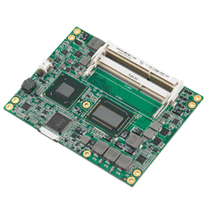
February, 2011– Advantech, the embedded platform and integration services provider announces a new series of embedded boards based on the new 2nd Generation Intel® Core™ i7 processor, featuring intelligent performance, power efficiency, and integrated Intel® HD graphics with DX10.1 support. As a premier member of the Intel® Embedded Alliance, Advantech is continuously developing and delivering cutting edge solutions based on the latest Intel® platforms with proven high performance, reliability, longevity and excellent design quality to help customers decrease time-to-market. The 2nd Generation Intel Core i7 processor-based platforms by Advantech range from Computer On Modules, Industrial Motherboards, Slot Single Boards to Embedded Systems. These high-end platforms provide targeted performance for multi-tasking and high-quality digital media solutions. They serve a wide range of applications that include: telecom, factory automation, military, medical and gaming.

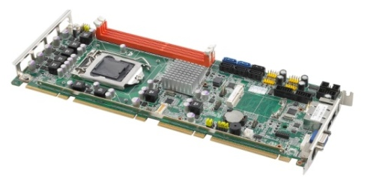
Utilizing the 2nd Generation Intel Core i7 processor and Intel® Q67 chipset, Advantech developed a new series of embedded platforms in various form factors that include: Industrial Motherboards, PICMG 1.3 SHB, and ATX based server-grade motherboards. Advantech’s MicroATX motherboard—AIMB-581 (244 x 244 mm), ATX motherboard—AIMB-781 (304.8 x 244 mm), and the PICMG 1.3 SBC—PCE-5126 (338.58 x 126.39 mm) feature intelligent performance, power efficiency,and integrated Intel HD graphics, DX10.1 and OpenGL 3.0. All of these products provide superb all-round performance, expandability, and versatility for media-demanding applications. ASMB-781 is a sub-entry UP industrial server board targeting industrial control, automation equipment and surveillance DVR applications. The range is highly impressive in its specialist layout design that enables good ventilation to match Advantech’s comprehensive chassis with multiple expansion cards including full length card support.

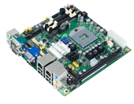
Based on the 2nd Generation Intel Core i7 processor and Intel® QM67 Express chipset, Advantech is releasing a COM-Express basic module—SOM-5890 (95 x 125 mm),that is compliant with the newly released PICMG COM.0 R2.0 type 6 specification. SOM-5890 supports memory with ECC/non-ECC versions, up to SATA 6Gb/s, PCI Express x16 Gen2, and integrated HDMI/DVI/Displayport display interfaces. With great performance and rich graphic interfaces, it is the most suitable solution for high processing, graphic intensive demands, and multi-display applications. Advantech will also be introducing a new industrial motherboard called AIMB-272, capable of SATA RAID 0, 1, 5 & 10 to ensure reliable storage and system protection for network-intensive applications, which brings top performance with power saving features to the Mini-ITX motherboard class.

Advantech not only provides a comprehensive range of Core processor-based boards, but also multi OS support, including Windows 7, XPe, WinCE, QNX, and Linux. Plus, a variety of intelligent API’s are bundled with the new boards to facilitate application development. To find out about the 2nd Generation of Intel Core processor-based boards and innovative embedded services, visit the website or contact your local sales.

About Advantech –Founded in 1983, Advantech delivers trustworthy industrial computing solutions that enable intelligent applications. Our operation is divided into two segments: Branded & Solution Business and Embedded Design-In Business. We cooperate closely with solution partners to provide products and customized solutions in a wide array of applications. Advantech operates an extensive support, sales and marketing network in 18 countries and 39 major cities to deliver fast time-to-market services to our worldwide customers. (Corporate Website: www.advantech.eu). For Telecom and Networking markets, Advantech provides mission-critical hardware to the leading telecom and networking equipment manufacturers. Advantech’s standard and customized products are embedded in OEM equipment that the world's communications infrastructure depends upon. Website: www.advantech.eu/NC

Intel and Intel Core are registered trademarks of Intel Corporation in the United States and other countries.
All product or service names mentioned herein are the trademarks of their respective owners

