Primary Media Contact:  Advantech Europe B.V.  Barbara Tritscher  Tel: +49 (0) 89 12599 1038  Barbara.Tritscher@advantech.de |  |  | 2nd Media Contact:

AIMB Mobile G-Series Mini-ITX Board
with Extended HD Graphics Performance

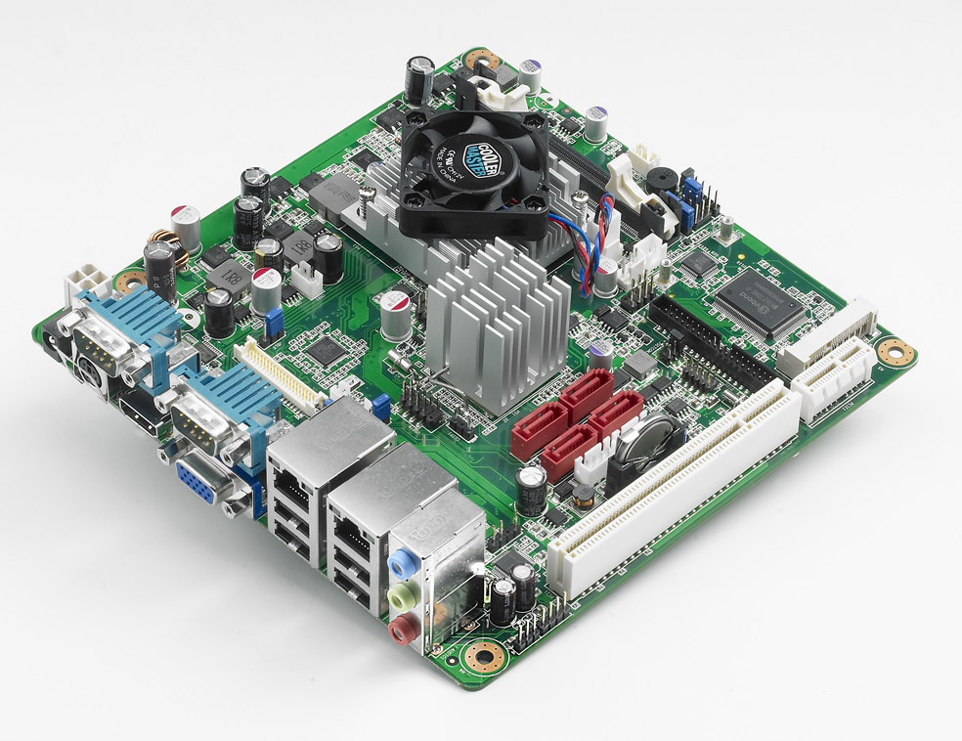
October 19, 2011–Advantech, the embedded platform and integration services provider, announces the introduction of a new industrial-grade, Mini-ITX motherboard supporting the latest AMD® G-Series processors. AMD G-Series feature intelligent performance, power efficiency, and integrated AMD HD Graphics with DX11 support. AIMB-223 is capable of SATA RAID 0, 1, 5 & 10 to ensure reliable storage and system protection for network-intensive applications.

AMD’s “Fusion” Architecture Accelerated Processing Unit
AMD's Fusion family of processors is considered an APU (Accelerated Processing Unit) because it integrates a CPU and a discrete-class GPU on the same die, thereby improving graphics data bandwidth while reducing power consumption.

Maximum Connectivity for Minimum Resources
The AIMB-223 board comes with high connectivity and a variety of expansion options including: a single PCIe x1 and PCI expansion slot, six serial ports, four SATA III 600 MB/s connectors, and eight USB 2.0 ports. Dual display output is supported with several output interface options: VGA, HDMI, and LVDS (LVDS supports 3.3V, 5V, and 12V for large sized panels). AIMB-223 also comes with software RAID 0, 1, 5 and 10 support, offering abundant data storage and reliable data protection, as well as dual PCI Express based Gigabit (Realtek 8111DL) Ethernet ports delivering up to 1000 Mbps of bandwidth for network-intensive applications. AIMB-223 has designed in both ATX12V and DC IN power to provide a low total cost solution. All this connectivity is packed into a space-saving, power-efficient, and cost-effective Mini-ITX form factor.

Dual Display and Excellent Graphics Performance
With the graphics engine integrated onto the processor chip, these two-chip solutions provide enhanced graphics performance compared to previous AMD platforms. The integrated graphics controller includes AMD’s first Fusion architecture accelerated processing unit which can also support dual channel 24-bit LVDS for large sized panels.

Integrated Intelligent Software API
Advantech provides drivers and APIs for different operating systems including GPIO, SMBus, watchdog timer, hardware monitor, panel backlight on/off, and brightness control. Supported operating systems include Windows 7, Windows XP, XPEmbedded, Windows CE, and Linux—hardware drivers for these OS are readily available. AIMB-223 is available now; please contact your local sales or visit the website (http://www.advantech.com.tw/embcore/) for more information.

Features:
- Supports AMD Mobile G-series Dual Core/Single Core processor
- One 204-pin SODIMM up to 4 GB DDR3 1333 MHz SDRAM
- Supports VGA/LVDS/HDMI
- Dual LANs, 6COMs, Mini PCIe, and Cfast
- Supports embedded software APIs and Utilities

###

About Embedded Core Service
Advantech Embedded Core Services offers design-in oriented services. These streamlined solutions broadly integrate embedded boards, peripheral modules and software. This dedicated focus on Embedded Design-in services fulfills electronic engineering demands at their design-in phase, and brings benefits that shorten the design and integration cycle, minimizing uncertainty and risk. www.advantech.eu/EmbCore

About Advantech
Founded in 1983, Advantech is a leader in providing trusted, innovative products, services, and solutions. Advantech offers comprehensive system integration, hardware, software, customer-centric design services, embedded systems, automation products, and global logistics support. We cooperate closely with our partners to help provide complete solutions for a wide array of applications across a diverse range of industries. Our mission is to enable an intelligent planet with Automation and Embedded Computing products and solutions that empower the development of smarter working and living. With Advantech, there is no limit to the applications and innovations our products make possible. (Corporate Website: www.advantech.eu).

