Primary Media Contact:
Advantech Europe
Pauline Huang
Tel: +31 (0) 40 267 70 84
pauline.huang@advantech.eu

New Generation Intel® Atom™ D525/D425 Embedded IPC with DDR3 Support and Integrated Display Interface

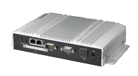
Eindhoven, April 18 –Advantech (2395.TW), a global leader in the embedded computing market, is happy to announce the embedded ARK-1503 system, a compact, fanless embedded IPC powered by an Intel® Atom™ D525/D425 processor with DDR3 support and integrated display interface. It enables much better power savings, while providing top performance and rich I/O capability. And one of two touch monitor connecting options can be selected depending on the particular application: an I-Panel link, or a golden finger. All-new design technology simplifies your application integrations with trouble-free solutions–ideal for kiosks, factory and machine automation control applications.

Do More with Less: Power Efficiency, Low-profile Design and Rich I/O
ARK-1503 is powered by the latest Intel® Atom™ D425 single core and D525 dual core processors with DD3 memory up to 2 GB for D425 and 4 GB for D525. With integrated graphics and memory controllers, these processors deliver graphics core rendering speeds from 200 to 400 MHz while maintaining excellent power efficiency. In addition to higher speeds and less power consumption, ARK-1503 also features low-profile design (230.6 x 133.0 x 44.4 mm) but still provides rich I/O capabilities and high bandwidth. It supports 1 x RS-232, 1 x RS-232/422/485 serial ports with auto-flow control, 4 x hi-speed USB 2.0, 2 x Giga-LANs, DIO, line-out, and LVDS. And the built-in 1 x Mini PCIe communication module expansion slot supports an external CF socket, and 2.5" SATA HDD. ARK-1503 alos supports wide operating temperature from -20℃ to 60℃.

Integrated Display Interface Design: I-Panel Link and Golden Finger
Advantech provides extendable and pluggable designs that integrate embedded IPCs and displays. The ARK-1503 with I-Panel link interface integrates LVDS, USB, Tx/Rx signals, audio, and DC power through a DB36 SCSI connector, so a single cable supports a touch panel with power, video, audio, and touch info. And the alternate, 164-pin golden-finger option carries everything, including power, video (LVDS HDMI), audio, USB, COM and touch panel signaling; it supports an ITM touch monitor by direct golden-finger docking, with no cable at all, yet system and monitor can be upgraded independently, for more flexibility, better stability, and easy installation.
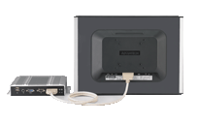
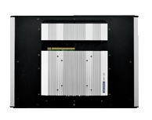

I-Panel Link Interface
Golden Finger Interface

Advantech will showcase ARK-1503 at Kiosk Europe 2011, and it is available at the end of April; please contact your local salesperson. To see more product information, visit our website: http://www.advantech.eu/applied-computing-systems/embedded-computer/default.aspx

ARK-1503
Intel® Atom™ D525/D425 Fanless Embedded IPC for Integrated Display Interface
- Intel® Atom™ D525/D425 processor up to 1.8 GHz
- Supports integrated LVDS interface, with LVDS / 2*USB / Rx / Tx signal (compliant with ITM-5115)
- Supports 2 Giga LAN and 4 USB 2.0 ports
- Supports 1 x RS-232, 1 x RS-232/422/485 with auto-flow control
- Built-in 1 x Mini PCIe expansion slot for communication module, like WLAN
- Supports external CF socket
- Supports easy-install 2.5" SATA HDD
- DC 12V power input
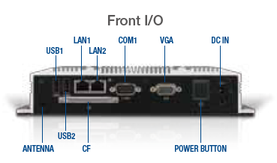
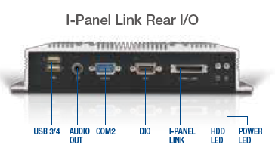
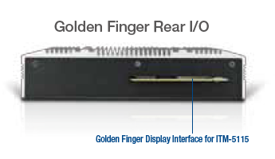

About Advantech
Founded in 1983, Advantech is a leader in providing trusted, innovative products, services, and solutions. Advantech offers comprehensive system integration, hardware, software, customer-centric design services, embedded systems, automation products, and global logistics support. We cooperate closely with our partners to help provide complete solutions for a wide array of applications across a diverse range of industries. Our mission is to enable an intelligent planet with Automation and Embedded Computing products and solutions that empower the development of smarter working and living. With Advantech, there is no limit to the applications and innovations our products make possible. (Corporate Website: www.advantech.eu).

