Customer Service Contact: Press Contact :
Advantech Europe Advantech Europe
Customer Care Center Lucia Falena
Tel: 00800 24 26 80 80 Tel : +39 029 544 9644
customercare@advantech.eu Lucia.Falena@advantech.it

PCI/PCIe Expandable Intelligent Embedded IPC
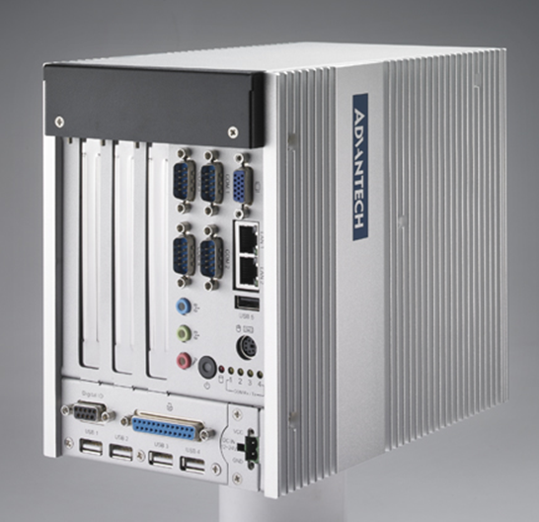
January, 2010 –Advantech (2395.TW), a global embedded computing leader providing embedded platform solutions across multiple vertical markets, has released an intelligent, fanless, embedded IPC with PCI/PCIe multi-expansion: the ARK-5260, a powerful, expandable, all-in-one system with ruggedized design. This compact embedded IPC is powered by an Intel® Atom™ D510 dual core processor up to 1.66 GHz. The ARK-5260 offers flexible expansion with 2 PCI slots and 1 PCIe x1 slot, rubber anti-vibration card-holder for PC expansion boards, two 2.5" SATA HDD bays to meet large storage demands, and front-side I/O interfaces to facilitate easy replacement and maintenance. It also supports wide-range 12~24V DC input and is packed into a small, rugged case. The ARK-5260 is targeted to satisfy customers looking for a robust and compact computing platform for machine automation, industrial plants, and cabinet integration.
Flexible PCI/PCIe Expansion
The ARK-5260 open frame embedded platform concept provides flexible PCI/PCIe expansion for a range of applications. It is compatible with raid controllers, motion cards, frame grabbers and isolated series ports for factory automation, facility automation, AOI (Auto Optical Inspection), and data acquisition applications. With the addition of a motion card and a video grabber, the ARK-5260 could form the basis for a visual inspection application, and with the video capture card alone, the rugged platform design makes an excellent choice for industrial DVR. The compact ARK-5260 system offers great controller interfaces for your applications.
Comprehensive Front-side I/O Interface
The comprehensive front-side I/O interface and optional accessories enable the ARK-5260 to accommodate a variety of scenarios. The ARK-5260 supports two 2.5” SATA HDDs, and has one 200-pin SODIMM slot for DDR2 667MHz memory up to 2GB, five USB 2.0 compliant ports and two GigaLANs. One VGA output, one 8-bit DIO, plus audio jacks, line-in/line-out, and mic in, all provide a great selection for display applications such as digital signage. Four RS-232/422/485 serial ports satisfy most industrial needs for signal control. ARK-5260 offers plenty of I/O expansion connectors and slots for industrial automation applications as well, such as LPT port and PS/2 connector.
High Tolerance to Shock and Vibration
Designed for harsh environments, the ruggedized system design withstands 5Grms vibration (Compact Flash), and passed 50G shock (Compact Flash). Outfitted with two 2.5” HDDs, the system can withstand 1Grms vibration, and passed 20G shock with flying colors. ARK-5260 without add-on cards can tolerate -20 ~ 55° C (with Compact Flash), and 0 ~ 45° C (with hard drive).
ARK-5260 will be available at the end of November; please contact your local salesperson. To see more suggested application possibilities, visit the website http://www.advantech.com/ePlatform/box-ipc/default.aspx

ARK-5260
Low Power Intel® Atom™ D510 Embedded IPC with 2 x PCI/ 1 x PCIe Expansion
- Sealed construction with fanless operation, supports Intel® Atom™ D510 up to 1.66 GHz
- Supports 2 Giga LAN and 5 USB 2.0 ports
- Supports 4 RS-232/422/485 with auto-flow control
- Built-in 1 x PCIe expansion slot, and 2 x PCI expansion slots
- Rubber anti-vibration card-holder for PC expansion boards
- Supports wide power range: 12~24V DC input
- IP40

About Advantech
Founded in 1983, Advantech is a leader in providing trusted, innovative products, services, and solutions. Advantech offers comprehensive system integration, hardware, software, customer-centric design services, embedded systems, automation products, and global logistics support. We cooperate closely with our partners to help provide complete solutions for a wide array of applications across a diverse range of industries. Our mission is to enable an intelligent planet with Automation and Embedded Computing products and solutions that empower the development of smarter working and living. With Advantech, there is no limit to the applications and innovations our products make possible. (Corporate Website: www.advantech.eu).

