Primary Media Contact:
Lucia Falena
Tel: +39 029 544 9644
Lucia.Falena@advantech.it

Advantech ARK-DS350 (AM3) Digital Signage Media Player with Strong Video Performance
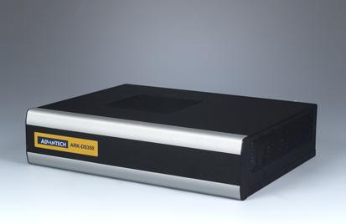
Advantech, the leading embedded platform and integration services provider, announces the release of new digital signage player. ARK-DS350 (AM3) is a high-end model powered by the AMD 780E and SB710 platform. It provides optimal graphic performance with advanced ATI Radeon™ 3200 graphics and DirectX 10 compliant hardware decoding. The on-board 128 MB of the dedicated DDR3 video memory can further optimize power saving and video decoding. It delivers superior 1080p performance and can comfortably support dual channel video. Advantech aims to target this new product with great cost/performance appeal at public transportation, retail, interactive displayand digital out-of-home advertising networks.
Optimum Graphics Platform
Advantech ARK-DS350 (AM3) is an advanced digital signage platform powered by AMD-780E and SB710 platform. It provides optimal graphic performance with advanced ATI Radeon™ 3200 graphics and DirectX 10 compliant hardware decoding. The discrete graphic chipset offers video acceleration via the unified hardware video decoder for H.264, VC-1, and MPEG 2, thus offering smooth full HD video playback and crisp image transitions. Furthermore, the on-board 128 MB of dedicated DDR3 video memory can further optimize power saving and video decoding—a perfect platform for digital signage applications where vivid multimedia playbackis the key to delivering high visual impact content.
Discrete Graphic Chipset for Optimal Performance
ARK-DS350 (AM3) is available in two computing performance levels: embedded AMD Athlon™ II XL dual-core processor version, or the low power AMD Sempron single-core processor version. This solution enables a single product design be able to support a wide range of performance and power points. ARK-DS350(AM3) delivers superior performance for 1080p HD output and can support dual channel video via HDMI and VGA. Furthermore, ARK-DS350 (AM3) is a relatively compact design, low profileand light weight, able to be easily installed behind any large size LCD display. Though this is a fan-based model, it leverages smart fan technology so that the fan runs quiet.

For more information please contact your local Advantech sales representative, or visit us at our website. http://www.advantech.com/applied-computing-systems/digital_signage/
Main Features:
‧AMD RS780E+ SB710 platform with value and high-end AMD CPU
‧Integrated ATI Radeon™ HD 3200 chip provides excellent graphics and DirectX® 10 high-definition hardware video decode
‧128 MB of dedicated DDR3 video memory on board
‧Two HDMI (1 x full-function; 1 x video only) and 1 VGA, supports full HD (1080p) for dual displays
‧Built-in Mini PCIe slot for easy expansion e.g. WiFi, TV-tuner
‧Supports 8 x USB 2.0 (External 4 +Internal 4), 2 x COM (Internal 1x COM)
###

About Advantech
Founded in 1983, Advantech is a leader in providing trusted, innovative products, services, and solutions. Advantech offers comprehensive system integration, hardware, software, customer-centric design services, embedded systems, automation products, and global logistics support. We cooperate closely with our partners to help provide complete solutions for a wide array of applications across a diverse range of industries. Our mission is to enable an intelligent planet with Automation and Embedded Computing products and solutions that empower the development of smarter working and living. With Advantech, there is no limit to the applications and innovations our products make possible. (Corporate Website: www.advantech.com).

