Primary Media Contact:  Advantech Europe B.V.  Pauline Huang  +31 (0) 40 267 70 84  Pauline.Huang@advantech.eu |  |  | 2nd Media Contact:

ISE 2012: Advantech’s New Open Pluggable Specification (OPS) Digital Signage Player Makes Digital Signage Applications Intelligent and Connected

Advantech released its Open Pluggable Specification (OPS) compliant digital signage player ARK-DS220. The ARK-DS220 complies with Intel OPS (Open Pluggable Specification) standard and is powered by an Intel Atom D525 dual-core processor (fan-based) and Intel Atom N455 single-core processor (fanless) with integrated NVIDIA GT218 (ION2) graphic module for Full HD playback. Compliant with the Open Pluggable Specification (OPS), its slot-in module design effectively lowers deployment and field maintenance costs to simplify device installation, usage, maintenance and upgrades. Advantech will showcase this OPS digital signage solution at ISE 2012 from 30th January to 2nd February 2012 in Amsterdam RAI.

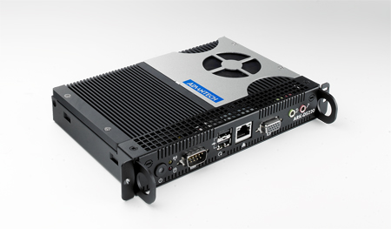 | 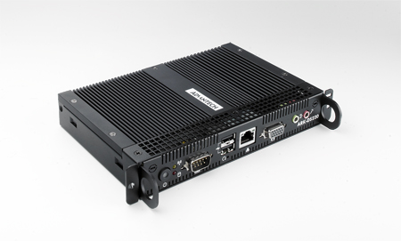
Intel Atom D525 dual-core processor (fan-based) | Intel Atom N455 single-core processor (fanless)
More Intelligent and Connected
ARK-DS220 OPS media player enables digital signage manufacturers to deploy systems faster, with lower costs for development and implementation. Its slot-in module is connected via a JAE 80-pin connector, and includes the HDMI, DVI-D, DP, UART, and USB2.0/USB3.0 signals. The player-screen communication interface via UART and HDMI CEC provides status reporting and control, and also supports digital audio/video signals via HDMI or display port, for picture-perfect content reproduction. ARK-DS220 also supports 1x GigaLAN, 1x COM ports, and 2x USB2.0 giving a great selection for data communication in display applications. The entire design makes digital signage applications more intelligent and connected.

ARK-DS220 will be officially launched to the market in July; Advantech will start to showcase ARK-DS220 in upcoming events. For more information please contact your local Advantech sales representative, or visit us at our website.
http://www.advantech.eu/applied-computing-systems/digital_signage/

ARK-DS220
Open Pluggable Specification (OPS) Digital Signage Player
• Integrated NVIDIA GT218 (ION2) graphic module for Full HD playback
• Intel Atom D525 dual-core (fan-based) or Intel Atom N455 single-core (fanless)
• Designed compliant with OPS (Open Pluggable Standard)
• Supports HDMI, DP, UART, and USB2.0/USB3.0 via JAE 80-pin connector
• Slot-in integration, easy maintenance

About Advantech
Founded in 1983, Advantech is a leaderin providing trusted, innovative products, services, and solutions. Advantech offers comprehensive system integration, hardware, software, customer-centric design services, embedded systems, automation products, and global logistics support. We cooperate closely with our partners to help provide complete solutions for a wide array of applications across a diverse range of industries. Our mission is to enable an intelligent planet with Automation and Embedded Computing products and solutions that empower the development of smarter working and living. With Advantech, there is no limit to the applications and innovations our products make possible. (Corporate Website: www.advantech.eu).

