|  |  |  |
| --- | --- | --- |
| **Primary Media Contact:**  Advantech Co., Ltd.  Tiffany Chou  Tel: +886-2-2792-7818, Ext. 7982  [Tiffany.Chou@advantech.com.tw](mailto:Tiffany.Chou@advantech.com.tw) | **Secondary Media Contact:** | **2nd Media Contact:** |

**Advantech’s Healthcare Infotainment Terminal Series:**

**First to Be Powered by the Android™ Operating System!**

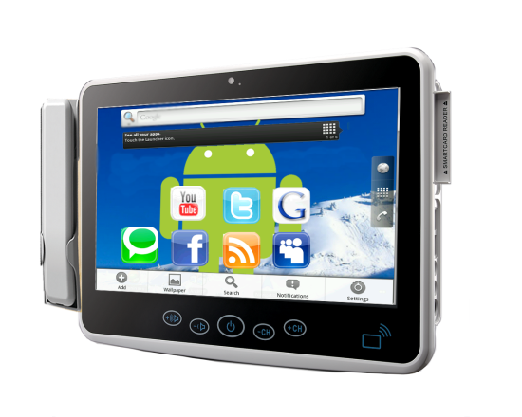

**Taipei, Apr 14, 2011** – Following successful ports to Windows® Embedded, Windows 7, and the Ubuntu and Fedora Linux distributions, the Advantech Applied Infotainment Terminal Division is pleased to announce that it has completed porting its Healthcare Infotainment Terminal (HIT) series to the Android 2.2 (Froyo) OS kernel. This marks the first Advantech product series that supports the growing Android platform. An application-ready software development kit (SDK) and drivers are also available for the Android operating system, bringing greater opportunities for cloud computing services in digital healthcare applications, such as patient infotainment systems, electronic patient data retrieval, patient identification systems and home care.

**Android™ is Already a Mature, Well-known Platform for Cloud Computing**

In just under two years, Android has become a widely used mobile operating system, powering everything from netbooks, to smart phones, to tablets. People are using all kinds of Android applications (“apps”) on surprising types of systems. At first, gaming and entertainment devices adopted Android, but as the operating system grew in popularity many new, creative and useful “apps” have hit the market; quite a few are serious business applications.

**Near Field Communication (NFC) Payments on Android Will Become a Mainstream Business Model in the Not Too Distant Future**

With Google’s strong support and promotion, Android devices are surfacing that feature near field communications. By embedding a small RFID sensor in the device, it can act like an electronic wallet, RFID debit card, or VISA Wave card, extending Android’s domain to point of sale use at the Metro, convenience stores, or for building security access, or anywhere else RFID smart technology can be used. In a determined move, Google has recently teamed up 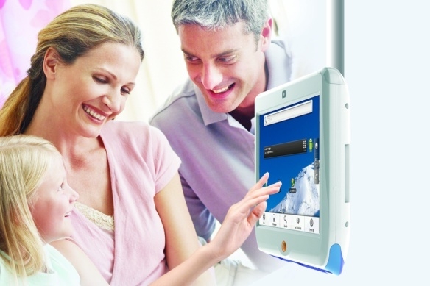with MasterCard and Citigroup to bring the NFC Payment System to the United States, launching a program in the San Francisco Bay and New York City areas. Soon customers using Citigroup cards will be able to activate an “app” designed specifically for NFC-enabled Android smart phones. The “app” will allow users to pay for purchases by waving their phones over a contact-less reader.

**The HIT Series is On Target for NFC Payments**

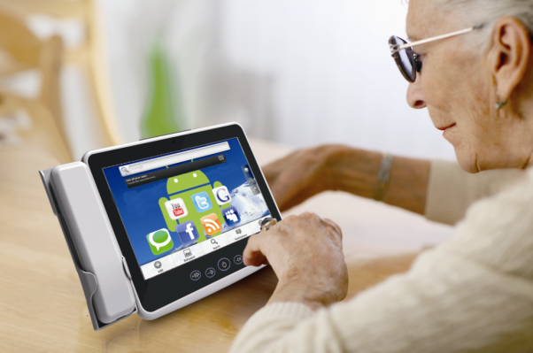With built-in RFID read/write sensors, and now with the power of Android, HIT series systems are perfectly poised to take advantage of the new NFC Payment “apps” entering the market. And with other features like built-in Wi-Fi and a Smartcard reader, HIT series products are a stellar choice for cloud service terminals in public places. They can connect to personal Android devices and process payments and transactions with the wave of a hand.

Advantech Healthcare Infotainment terminals are designed to satisfy the growing demand for faster, safer and more reliable communication systems by enhancing quality of service and boosting efficiency at hospitals and other healthcare-related facilities. The full product line consisting of 12.1”, 15.6”, and 18” touch-enabled terminals will be on the market in the first half of 2011. Meet us at WoHIT in Budapest, 10-12th May 2011, booth number 635 and experience our medical computing products.

For more information please contact an Advantech sales representative, or visit the website at: [www.advantech.com](http://www.advantech.com).

###

**About Advantech**

Founded in 1983, Advantech is a leader in providing trusted, innovative products, services, and solutions. Advantech offers comprehensive system integration, hardware, software, customer-centric design services, embedded systems, automation products, and global logistics support. We cooperate closely with our partners to help provide complete solutions for a wide array of applications across a diverse range of industries. Our mission is to enable an intelligent planet with Automation and Embedded Computing products and solutions that empower the development of smarter working and living. With Advantech, there is no limit to the applications and innovations our products make possible. (Corporate Website: [www.advantech.com](http://www.advantech.com/))