|  |  |  |  |
| --- | --- | --- | --- |
| **Primary Media Contact:**  Advantech Europe B.V.  Pauline Huang  +31 (0) 40 267 70 84  [Pauline.Huang@advantech.eu](mailto:Pauline.Huang@advantech.eu) |  |  | **2nd Media Contact:** |

**Advantech GPRS IP Gateway for IoT Connectivity Solutions**

**Nov, 2011** - Advantech announced two new IP gateways; the EKI-1321 and 1322 GPRS have been designed to ensure that networks are always connected. With dual SIM slots, designed to support GPRS signal redundancy which automatically switch to any available channel if the other one is disconnected and an SD slot for data buffering and auto recovery to prevent loss of serial data if the communication is interrupted the EKI-1321 and 1322 always provide reliable and redundant communication.

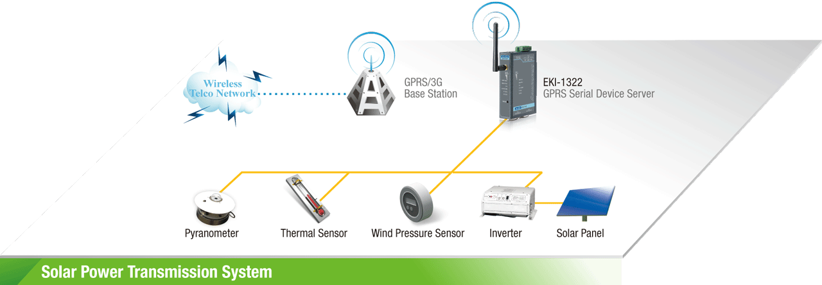

EKI-1321 and EKI-1322 are cellular gateways that can transparently bring RS-232/422/485 or Ethernet devices to a cellular network. They allow nearly any device with serial or Ethernet ports to connect and share a cellular network with an easy and simple configuration.

EKI-1321 and EKI-1322 GPRS IP Gateway's are compact, and can be DIN-rail or wall mounted; coming with both front panel and side panel LED displays for easy identification. Each device also includes dual DC power input from 12 to 48 VDC and have 2KV EFT/surge protection to prevent damage from various types of power resources. The serial ports are also protected by 15KV ESD line protection to keep your system safe from unexpected electrical discharges.

**Cellular IP Gateway Product Family**

Advantech’s IP gateway product portfolio includes GPRS version (EKI-1321/1322), 3G version (EKI-1331/1332), Wireless Sensor Network version (EKI-1321Z), and GPRS programmable version (EKI-1321P), and WLAN 802.11n version (EKI-1511/1522).

The key features are as follows:

* Universal quad-band GSM/GPRS 850/900/1800/1900 MHz
* Dual SIM slots for telecom redundancy
* SD slot with extra SD card for data buffering
* Ethernet and serial ports
* Various Operating modes: COM port redirector, RVCOM, TCP, UDP, SMS tunnel, and pair connections
* Any baud rate setting for easy configuration
* 2 digital inputs (EKI-1321)
* Multiple configuration methods: Windows utility, Telnet, and Web console
* Supports Windows 2000/XP/Vista/7, Windows CE and Linux drivers

###

About Advantech

Founded in 1983, Advantech is a leader in providing trusted, innovative products, services, and solutions. Advantech offers comprehensive system integration, hardware, software, customer-centric design services, embedded systems, automation products, and global logistics support. We cooperate closely with our partners to help provide complete solutions for a wide array of applications across a diverse range of industries. Our mission is to enable an intelligent planet with Automation and Embedded Computing products and solutions that empower the development of smarter working and living. With Advantech, there is no limit to the applications and innovations our products make possible. (Corporate Website: [www.advantech.eu](http://www.advantech.eu)).