Primary Media Contact:  Advantech Europe B.V.  Barbara Tritscher  Tel: +49 (0) 89 12599 1038  Barbara.Tritscher@advantech.de |  |  | 2nd Media Contact:

Advantech Ultra Small SBC with High Extension Flexibility
MIO-2260 Powered by Intel® Atom™ N455 Processor

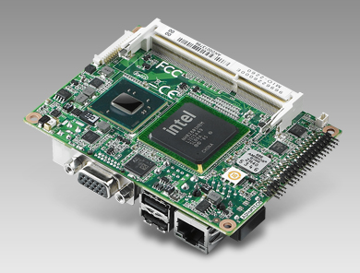
October, 2011 –Advantech, a global embedded computing leader providing smart solutions across multiple vertical markets, today announced the arrival of MIO-2260. MIO-2260 is designed with the Intel® Atom™ N455 single core processor and DDR3 memory support. It is an all-in-one ultra small size embedded Single Board Computer (SBC) measuring only 100 x 72 mm (same dimension as 2.5” Hard Disk) which is easy to embed into space-limited systems, making it a perfect fit for power saving environments.

MIO-2260 not only features low power consumption and small footprint, but it is also equipped with flexible multiple I/O expansion and interfaces. This small all-in-one module helps deliver more efficient scheduling using less development resources and helps customers retain their specialist domain knowhow. MIO-2260’s integrated LVDS display and touch panel transmission interfaces achieve high-speed data processing and excellent graphics capabilities—making MIO-2260 SBC perfect for small HMI and high performance industrial control machine applications. MIO-2260’s compact size also makes it suitable for embedded handheld devices, industrial equipment, medical, and intelligent home automation.

MI/O Extension Provides Flexible Efficient Development
MIO-2260 provides flexible modular design capability for customers through its innovative MIOe interface. Advantech also provides a reference design guide and test evaluation board for the customer who wants to design modules in simpler way. By connecting with MIOe unified connector through high speed sockets, customers get additional flexible I/O choices to fulfill different vertical applications. MIO-2260 integrates several interfaces on the MIOe connector which include compatibility for 4 x PCIe x1, 3 x USB 2.0, Audio Line-out ,SMbus and LPC, as well as 5Vsb , 12Vsb and power control signal. MIOe modules can be completely customized to meet customers’ requirements as well as saving their investment cost and shortening development schedules.
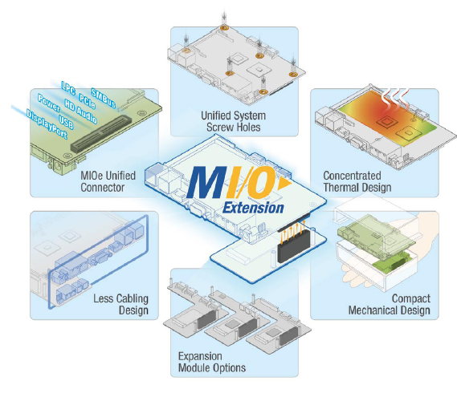

Innovative Mechanical Design for Easy Integration and Cost Savings
The mechanical design of MIO-2260 has the heat-generating parts and active components placed on the top side of the board, and the onboard I/O and rear I/O placed on the bottom side to make it easier to design a more efficient thermal spread result. In addition, MIO-2260 has an optional heat spreader to make thermal design easier and more efficient. Using a heat spreader to conduct the heat to the chassis cover makes more compact and low-profile designs possible than using a traditional heatsink, as well as giving better thermal dissipation. The MI/O Extension design means less wiring in systems, further reducing manual installation cost, and reducing the size of the final product.

Advantech Reliability Enhancement Design
MIO-2260 features a single 12V DC power input design which makes it easier for power integration. MIO-2260 also supports a DC power hot-plug protection design which can protect it from current fluctuations damaging the board when using DC power directly. To be more reliable and able to endure extreme environments, Advantech’s MIO-2260 was designed with a high level industrial grade ESD COM port driver IC (15KV air protection/8KV contact protection for RS-232), 100% solid capacitors with better MTBF compared with electrolytic capacitors, and TG-150 PCB type that allows the PCB to endure higher temperatures. MIO-2260 is a reliable single board computer solution that is well designed, using high quality materials—all backed up by advanced customization and integration services.

Cloud Computing Client Device with SUSIAccess and Emb’Store
MIO-2260 is directly supported from Advantech’s new cloud-based service—Emb’Store, which delivers on-demand services for embedded computing customers. Emb’Store offers the latest embedded hardware device drivers, BIOS updates and API’s, as well as 3rd party applications and specific embedded software. One such value added application is SUSIAccess which is used to monitor and manage multiple terminal devices as well as configure, maintain and recover them. It not only actively detects embedded devices, but also saves related data on the server for subsequent evaluation. SUSIAccess can remotely recover a system by simply clicking a restore button to recover the whole system. These remote operations can significantly reduce the maintenance and manpower costs arising from on-site visits.

Features:
- Embedded Intel® Atom™ N455 Single Core + ICH8M, DDR3 memory support
- Intel Gen 3.5 DX9, MPEG2 Decode in HW, Dual Independent display: 18-bit LVDS + VGA
- Supports 12 V +/- 10% input power and DC power hot plug design
- One Intel GbE, Rich I/O interface with 2 x COM, 1 x SATA, 2 x USB 2.0, 8-bit GPIO, Audio Line-in/out, SMBus, I2C, CF, half-size mini-PCIe
- Extended Interface support from MIOe: 4 x PCIe x1, LPC, SMBus, 3 x USB 2.0, audio line-out
- 15KV Air ESD protection COM port design
- Supports Advantech’s SUSIAccess and embedded Software API and Utility.
- WinCE6.0, Windows XP/XP Embedded, Windows 7, WES7, QNX, and Vxwork OS Support
- MI/O Extension- Ultra series: 100 x 72 mm (3.9" x 2.8")
- Thermal Solutions: Fanless design MIO-2260, with optional heat spreader solution for bundling which makes whole system more compact.

MIO-2260 will be available by end of November, 2011, for more information about MIO-2260 or new form factor MI/O Extension, please contact a local sales office, or visit us on the web at http://www.advantech.com.tw/embcore/.

###

About Embedded Core Service
Advantech Embedded Core Services offers design-in oriented services. These streamlined solutions broadly integrate embedded boards, peripheral modules and software. This dedicated focus on Embedded Design-in services fulfills electronic engineering demands at their design-in phase, and brings benefits that shorten the design and integration cycle, minimizing uncertainty and risk. www.advantech.eu/EmbCore

About Advantech
Founded in 1983, Advantech is a leader in providing trusted, innovative products, services, and solutions. Advantech offers comprehensive system integration, hardware, software, customer-centric design services, embedded systems, automation products, and global logistics support. We cooperate closely with our partners to help provide complete solutions for a wide array of applications across a diverse range of industries. Our mission is to enable an intelligent planet with Automation and Embedded Computing products and solutions that empower the development of smarter working and living. With Advantech, there is no limit to the applications and innovations our products make possible. (Corporate Website: www.advantech.eu).

