|  |  |  |
| --- | --- | --- |
| **Primary Media Contact:**  Advantech Co., Ltd.  Tiffany Chou  Tel: +886-2-2792-7818, Ext. 7982  [Tiffany.Chou@advantech.com.tw](mailto:Tiffany.Chou@advantech.com.tw) | **Secondary Media Contact:** | **2nd Media Contact:** |

**Advantech’s New Super Lightweight 15.6” Patient Infotainment Terminal Supports Full HD Resolution**

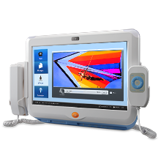**Taipei, Apr 20, 2011** – Advantech, a leading medical computing platform service and solution provider, announces the release of a new super lightweight 15.6” all-in-one interactive bedside terminal – PIT-1502W. High-end image and video quality at full HD resolution (1080p) are well catered for and best of all, it only weighs 4.8 kg. Designed for patient bedside entertainment, and for Patient Flow Management by medical professionals, the up-scaled features of PIT-1502W make the hospital stay experience easier and more pleasant with the addition of video and voice communications, TV, radio, movies, games and the Internet—all from a single conveniently located terminal in a patient-centered healthcare environment.

PIT-1502W is powered by Intel’s first dual core ATOM processor. The ATOM D510 is a desk-top class processor with integrated GPU and memory controller on die. The processor supports full HD (1080p) resolution and digital TV (ATSC/DVBT) formats, making this platform perfect for all round digital entertainment and communication purposes. The patient experience is further enhanced through access to the latest information on their condition, as well as helping them keep in touch with family and friends through VOIP, email and instant messaging.

Advantech’s PIT-1502W benefits medical staff and care professionals by aiding Patient Flow Management and providing secure access to Electronic Medical Record (EMR) data. As an 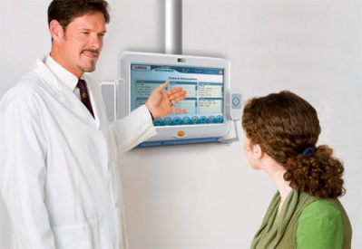aid to professional diagnosis, the terminal can remotely retrieve patient EMR, access databases from the bedside, and comply with Hospital Information Systems (HIS) requirements. Hospital administrators will see their medical facilities gain operational efficiencies, increase patient and visitor satisfaction, and improve their quality of care, while boosting profitability.

PIT-1502W is equipped with a 15.6" multi-function TFT touch screen, smart card reader and 2 megapixel camera. For customization, several optional peripherals are available such as WiFi, barcode scanner, RFID, handset and remote control, and VESA mount swing arm for convenient portable mounting on trolleys, and dining tables. As a member of the Advantech PIT family, PIT-1502W complies with medical certifications EN-60950 and EN-60601-1, and IP65 and NEMA 4 ratings, and it meets strong anti-shock requirements of 30G. Last but not least, PIT-1502W provides an IP phone, nurse call, and emergency alarm functions.

Thanks to a solid design running on XPE Embedded/Win 7/Linux Ubuntu/Fedora or Android, patients can enjoy full digital access to their family and friends. Secure identification recognition for both hospital staff and patients with the RFID and smart card reader makes sure care givers maximize their professional skills with aid of all the hospital systems at their disposal.

Advantech is committed to offering medical products that provide the very best in medical healthcare to staff and patients. Advantech’s healthcare products and services foster a smarter, interconnected healthcare environment. PIT-1502W is available now, please contact your local sales office or visit the website for more details. Meet us at WoHIT in Budapest, 10-12th May 2011, booth number 635 and experience our medical computing products.

###

**About Advantech**

Founded in 1983, Advantech is a leader in providing trusted, innovative products, services, and solutions. Advantech offers comprehensive system integration, hardware, software, customer-centric design services, embedded systems, automation products, and global logistics support. We cooperate closely with our partners to help provide complete solutions for a wide array of applications across a diverse range of industries. Our mission is to enable an intelligent planet with Automation and Embedded Computing products and solutions that empower the development of smarter working and living. With Advantech, there is no limit to the applications and innovations our products make possible. (Corporate Website: [www.advantech.com](http://www.advantech.com/))