Primary Media Contact:  Advantech Europe BV  Mariette Dusseldorp  Tel: +31 165 585082  Mariette.dusseldorp@advantech.nl |  | 2nd Media Contact:

Advantech’s Medical Grade, Fanless, Point-of-Care Terminals:
Performance at an Attractive Price

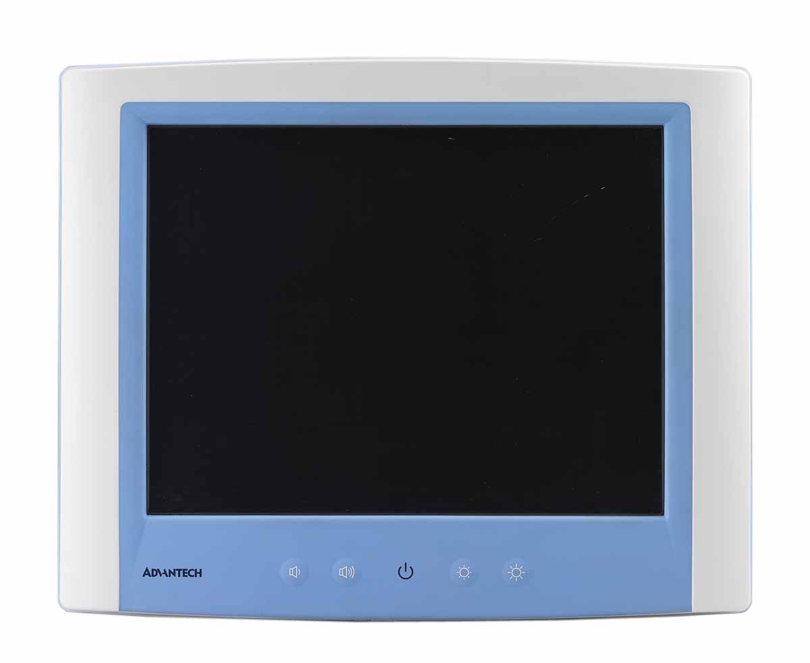
Taipei, March 18, 2011 – Advantech (2395.TW), a global embedded computing leader providing embedded platform solutions across multiple vertical markets, is happy to announce the release of a full range of medical-grade, fanless Point-of-Care terminals, the POC-C series terminals, designed for use in hospital operating rooms, ICUs, patient monitoring, and on computer carts. The 15”, 17” and 19” medical grade devices are positioned as cost-effective, entry-level systems that deliver competitive performance with a low investment cost. They are medically certified, and make an ideal solution for customers who want high quality medical computing systems at an attractive price.

Fanless, Medical-grade Platforms

Advantech POC-C series terminals are medical-grade devices. They are IEC60601-1 compliant, as well as CE, CCC and FCC Class B certified. The fanless design ensures quiet operation with low audible noise, making them suitable for bedside placement or for use in applications that involve audio measurements or testing. The terminals comply with IP65 or IP54 (POC-C197) standards of to ensure they are dust and water tight; they are easy to clean and maintain with hospital disinfectants helping prevent bacterial contamination.

Energy-saving Design

POC-C series medical computing terminals operate efficiently, designed to save cost while providing great performance. The units feature an energy-saving design that allows for low power consumption of only 28-48 watts during normal operations. They also support a wide range of electrical inputs (12-24V). POC-C series terminals are ideal for patient monitoring and computer cart applications.

Stability and Mobility

Mounting on computer carts adds mobility to the POC-C series terminals and the internal WLAN antenna ensures access to Hospital Information Systems from anywhere in the hospital or clinic. They are built tough, with the ability to withstand 20G shock and 1G vibration, providing reliability for critical applications.

Advantech’s POC-C series medical computing terminals allow hospitals and clinics to make use of advanced technology at affordable prices. They are available now. For more information, contact an Advantech sales office or visit our website: http://www.advantech.eu/sector/medical/default.aspx.

###
About Advantech
Founded in 1983, Advantech is a leader in providing trusted, innovative products, services, and solutions. Advantech offers comprehensive system integration, hardware, software, customer-centric design services, embedded systems, automation products, and global logistics support. We cooperate closely with our partners to help provide complete solutions for a wide array of applications across a diverse range of industries. Our mission is to enable an intelligent planet with Automation and Embedded Computing products and solutions that empower the development of smarter working and living. With Advantech, there is no limit to the applications and innovations our products make possible. (Corporate Website: www.advantech.eu).

